For research article
Response to Reviewer 3 Comments
Point-by-point response to Comments and Suggestions for Authors
Comments 1: In Section 4.1.4, PCA is used before network training, with the reduced dimension fixed at 30 for all datasets. Since the dimension setting of PCA may influence the retained spectral information and final clustering performance, a sensitivity analysis on the PCA dimension should be added.
Response 1:
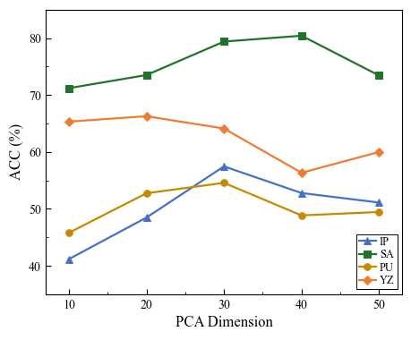
We sincerely thank the reviewer for this insightful suggestion. We agree that the number of retained principal components significantly impacts the preservation of spectral information and the subsequent clustering performance. Accordingly, we have conducted a systematic sensitivity analysis on the PCA dimension, and the corresponding results and discussions have been incorporated into the revised manuscript.
In this experiment, we varied the PCA dimension $d∈\{10,20,30,40,50\}$ across the four datasets. The variations in clustering accuracy are illustrated in the newly added Fig. 9. As observed in Fig. 9, increasing the PCA dimension from 10 to 30 leads to a general improvement in unsupervised clustering accuracy across the datasets. A higher dimension preserves more discriminative spectral information. However, when d exceeds 30, the performance tends to stabilize or decrease. Although a larger dimension includes more spectral information, it inevitably introduces redundant spectral components and noise associated with higher-order principal components, which can interfere with the unsupervised clustering process.
Specifically, as shown in Fig. 9, the proposed network achieves the highest clustering accuracy (ACC) at d=30 for the Indian Pines (IP) and Pavia University (PU) datasets. For the Salinas (SA) dataset, the accuracy peaks slightly higher at d=40, whereas for the YZ dataset, the optimal dimension is d=20. Despite these minor dataset-specific variations, setting d=30 yields consistently competitive and robust performance across all four datasets. Therefore, to achieve an optimal balance among the preservation of essential spectral information, the suppression of noise, computational efficiency, and experimental consistency, we have selected d=30 as the unified PCA dimension for all experiments.
Location in the revised manuscript:Section 4.5, “Sensitivity Analysis of PCA Dimension,” immediately after Section 4.4 “Attention Mechanism Analysis” and before the Discussion section. A new figure showing the ACC curves under different PCA dimensions has also been added.
Revised manuscript text：
“PCA is utilized to reduce spectral redundancy and extract the most informative spectral features prior to training the proposed network. Since the number of retained principal components significantly impacts the preservation of spectral information, we conducted a systematic sensitivity analysis by varying the PCA dimension $d∈10,20,30,40,50$across the four datasets.
As observed in Fig. 9, increasing the PCA dimension from 10 to 30 leads to a general improvement in unsupervised clustering accuracy across the datasets, as a higher dimension preserves more discriminative spectral information. However, when d exceeds 30, the performance tends to stabilize or decrease. Although a larger dimension includes more spectral information, it inevitably introduces redundant spectral components and noise associated with higher-order principal components, which can interfere with the unsupervised clustering process. Specifically, as shown in Fig. 9, the proposed network achieves the highest clustering accuracy (OA) at d=30 for the IP and PU datasets. For the SA dataset, the accuracy peaks slightly higher at d=40, whereas for the YZ dataset, the optimal dimension is d=20. Despite these minor dataset-specific variations, setting d=30 yields consistently competitive and robust performance across all four datasets. Therefore, to achieve an optimal balance among the preservation of essential spectral information, the suppression of noise, computational efficiency, and experimental consistency, we selected d=30 as the unified PCA dimension for all experiments.”

Comments 2: The parameter α in Eq. (15) is introduced as a degree-of-freedom parameter, but its value is missing from the implementation details. The authors should specify the value used in the experiments.
Response 2: Thank you very much for pointing out this missing parameter. Special thanks to the reviewers for their careful reading. We have revised and supplemented the manuscript accordingly for the omission of this parameter. All experiments in this paper use the same values for all datasets, and the degrees of freedom parameter in Student's t-distribution is fixed to α = 1.0 following the standard DEC setting, and will not be individually tuned.
Location in the revised manuscript: Section 4.1.4 (Implementation Details), in the paragraph describing the second-stage DEC optimization.
Revised manuscript text:
“The training is performed in two consecutive stages. In Stage 1, the autoencoder is pretrained to minimize the reconstruction loss using the Adam optimizer with a learning rate of $1×10^{−3}$. The number of pretraining rounds for the IP, SA, PU, and YZ datasets is set to 200, 300, 600, and 800, respectively. Stage 1 initializes the encoder and decoder weights and enables the network to learn preliminary feature representations with spectral-spatial structure. In Stage 2, the encoder and decoder weights pretrained in Stage 1 are used to initialize the clustering network. The encoder extracts latent features from the input data, and k-means is applied to initialize the cluster centers. The DEC-based clustering algorithm then iteratively updates the latent feature representation and cluster centers by minimizing the KL divergence between the target distribution P and the soft assignment distribution Q, with the degree-of-freedom parameter in Student's t-distribution fixed at α=1 for all datasets.The clustering loss weight is set to 1.0, and the learning rate is set to $1×10^{−4}$. All experiments were implemented using PyTorch on an NVIDIA GeForce RTX 4090 GPU.”

Comments 3: In Eq. (13), the subscript in Softmax_f suggests a frequency-wise normalization, but the corresponding tensor dimension is not explicitly defined. Please clarify whether Softmax is applied along the frequency dimension, channel dimension, or another axis.
Response 3: We sincerely thank the reviewer for pointing out this ambiguity. The $({Softmax}_{f})$ operation in Equation (13) is applied along the frequency dimension (N_f), rather than along the channel dimension. To clarify the mathematical formulation, we have explicitly specified the tensor shapes and the normalization axis in the revised manuscript.Specifically, for each attention head, the frequency-domain tensors$(Qf)$, $(Kf)$, and $(Vf)$ have the shape $(B×h×N_{f}×d_{h})$, where (B) denotes the batch size, (h) denotes the number of attention heads, (d_h) denotes the feature dimension of each head, and $(N_{f}=⌊N/2⌋+1)$ denotes the number of frequency components obtained by applying the real-valued fast Fourier transform to a token sequence of length (N). For each batch element, attention head, and feature channel, $(Softmaxf)$independently normalizes the query-key cross-spectrum along the (N_f) dimension. The resulting normalized frequency attention map is subsequently multiplied element-wise with the corresponding frequency components of $(V_{f}).$
Following the reviewer’s constructive suggestion, we have added these detailed explanations below Equation (13) in Section 3.4.2, ``Frequency-Domain Self-Attention'' of the revised manuscript.

Revised manuscript text:
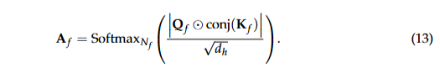
“Specifically, the frequency-domain tensors $(Qf)$, $(Kf)$, and $(Vf$) have the shape $(B×h×N_{f}×d_{h})$, where (B) denotes the batch size, (h) denotes the number of attention heads, ($d_{h}$) denotes the feature dimension of each attention head, and ($N_{f}=⌊N/2⌋+1$) denotes the number of frequency components obtained from a token sequence of length (N). For each batch element, attention head, and feature channel, the $(Softmaxf)$ operation is independently applied along the frequency dimension ($N_{f}$). The resulting normalized query-key cross-spectrum is then used to modulate the corresponding frequency components of the value tensor $(V_{f})$.”
Comments 4: Figure 1 is helpful for understanding the overall framework, but some labels inside the HSFIM, FFAB, and FreqViT blocks are difficult to recognize at the current scale. The figure should be enlarged and its layout adjusted.
Response 4: We sincerely thank the reviewer for this constructive feedback. We agree that the original Figure 1 was overly dense, making the internal labels of the HSFIM, FFAB, and FreqViT blocks difficult to recognize. To enhance the readability and clearly illustrate the network architecture, we have comprehensively redesigned the visual presentation by decoupling the overall framework from the specific sub-modules. Specifically, we have made the following improvements:
- Optimized Overall Architecture (Fig. 1): We have redrawn Figure 1 at a higher resolution with larger fonts, thicker connection lines, and wider spacing between modules. This revised figure now focuses clearly on the high-level training flow and the overall model architecture.
- Detailed Sub-module Diagrams (Figs. 2, 3, and 4): Instead of compressing all implementation details into a single diagram, we have provided separate, standalone figures for the internal blocks to ensure all labels and operations are clearly recognizable. Specifically, the detailed architectures of HSFIM, FFAB, and FreqViT are now illustrated in Fig. 2, Fig. 3, and Fig. 4, respectively.

Revised manuscript text:
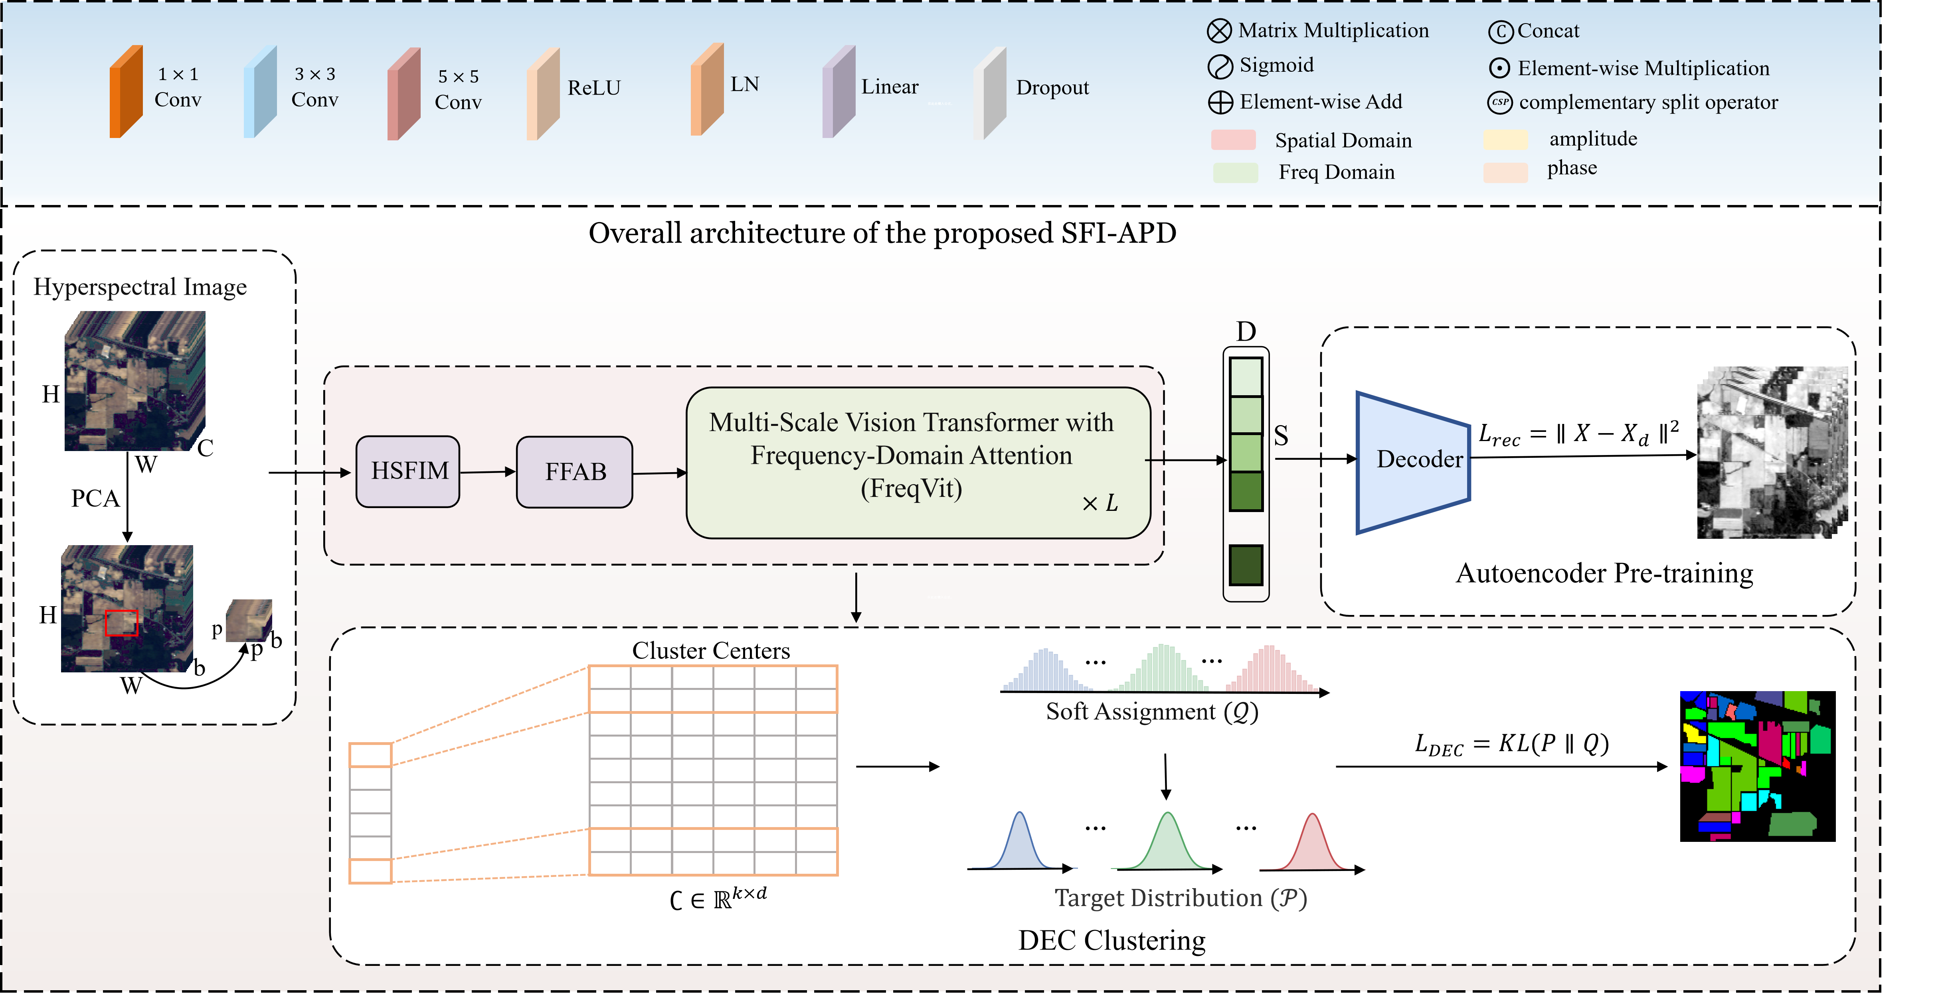
“Figure 1. Overall architecture of the SFI-APD framework. Firstly, the High-order space-frequency interactive module (HSFIM) was used to fuse the space-frequency features of the hyperspectral image after PCA dimension reduction. Then frequency feature Attention Block (FFAB) decouples the features fused with spatial-frequency information from amplitude and phase to suppress the spectral distortion caused by illumination and retain structural information. Finally, the Frequency Domain Vision Transformer (FreqViT) captures long-range dependencies under a self-supervised optimization strategy for feature representation learning with clustering optimization.”
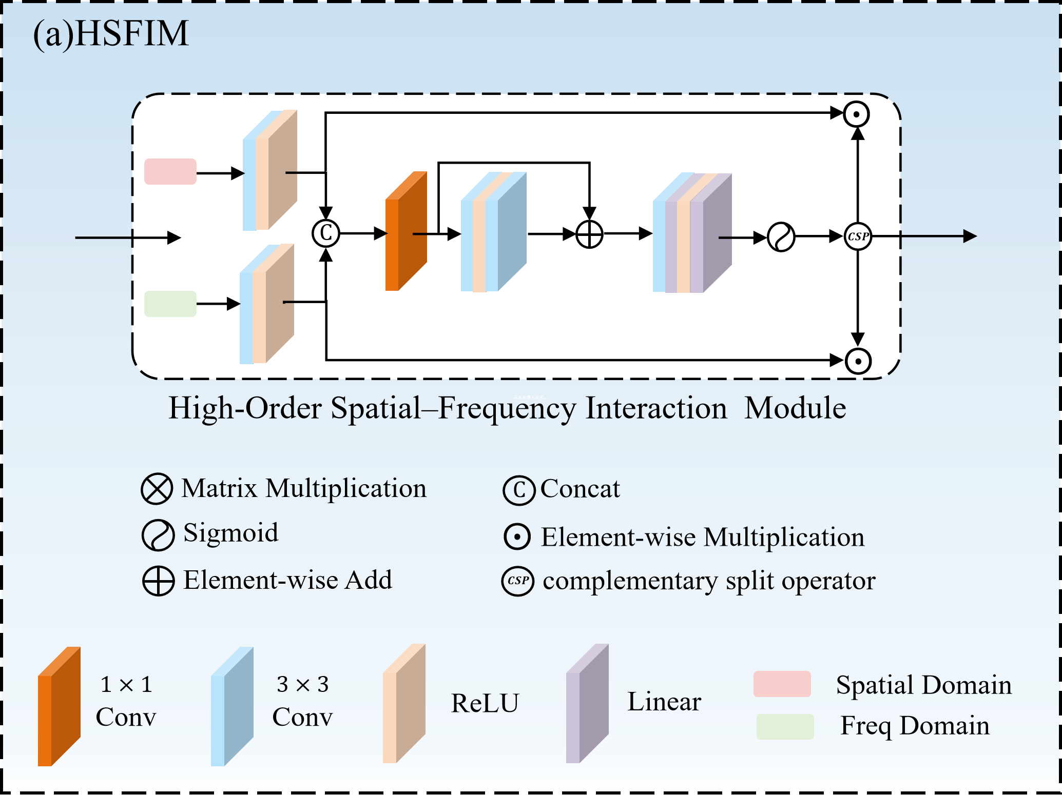
Figure 2. Detailed architecture of HSFIM

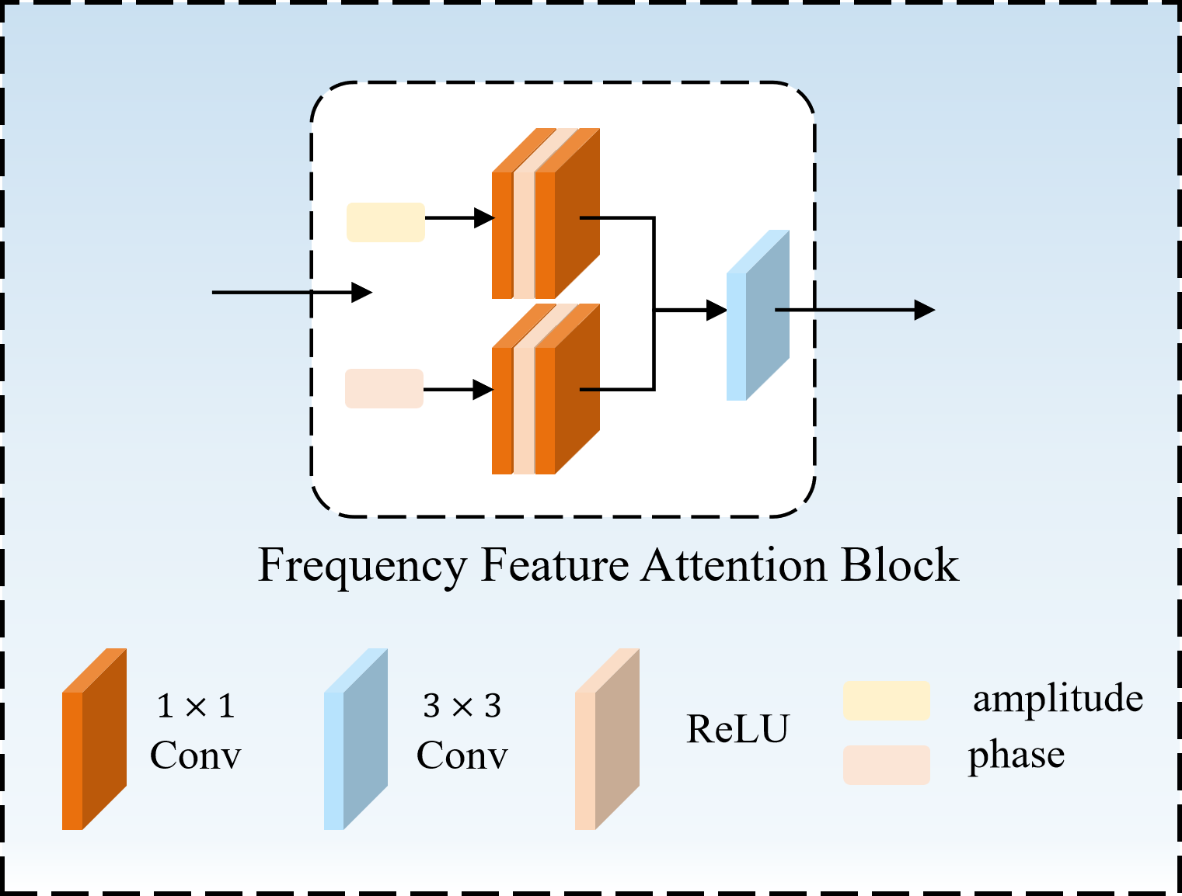
Figure 3. Detailed architecture of FFAB

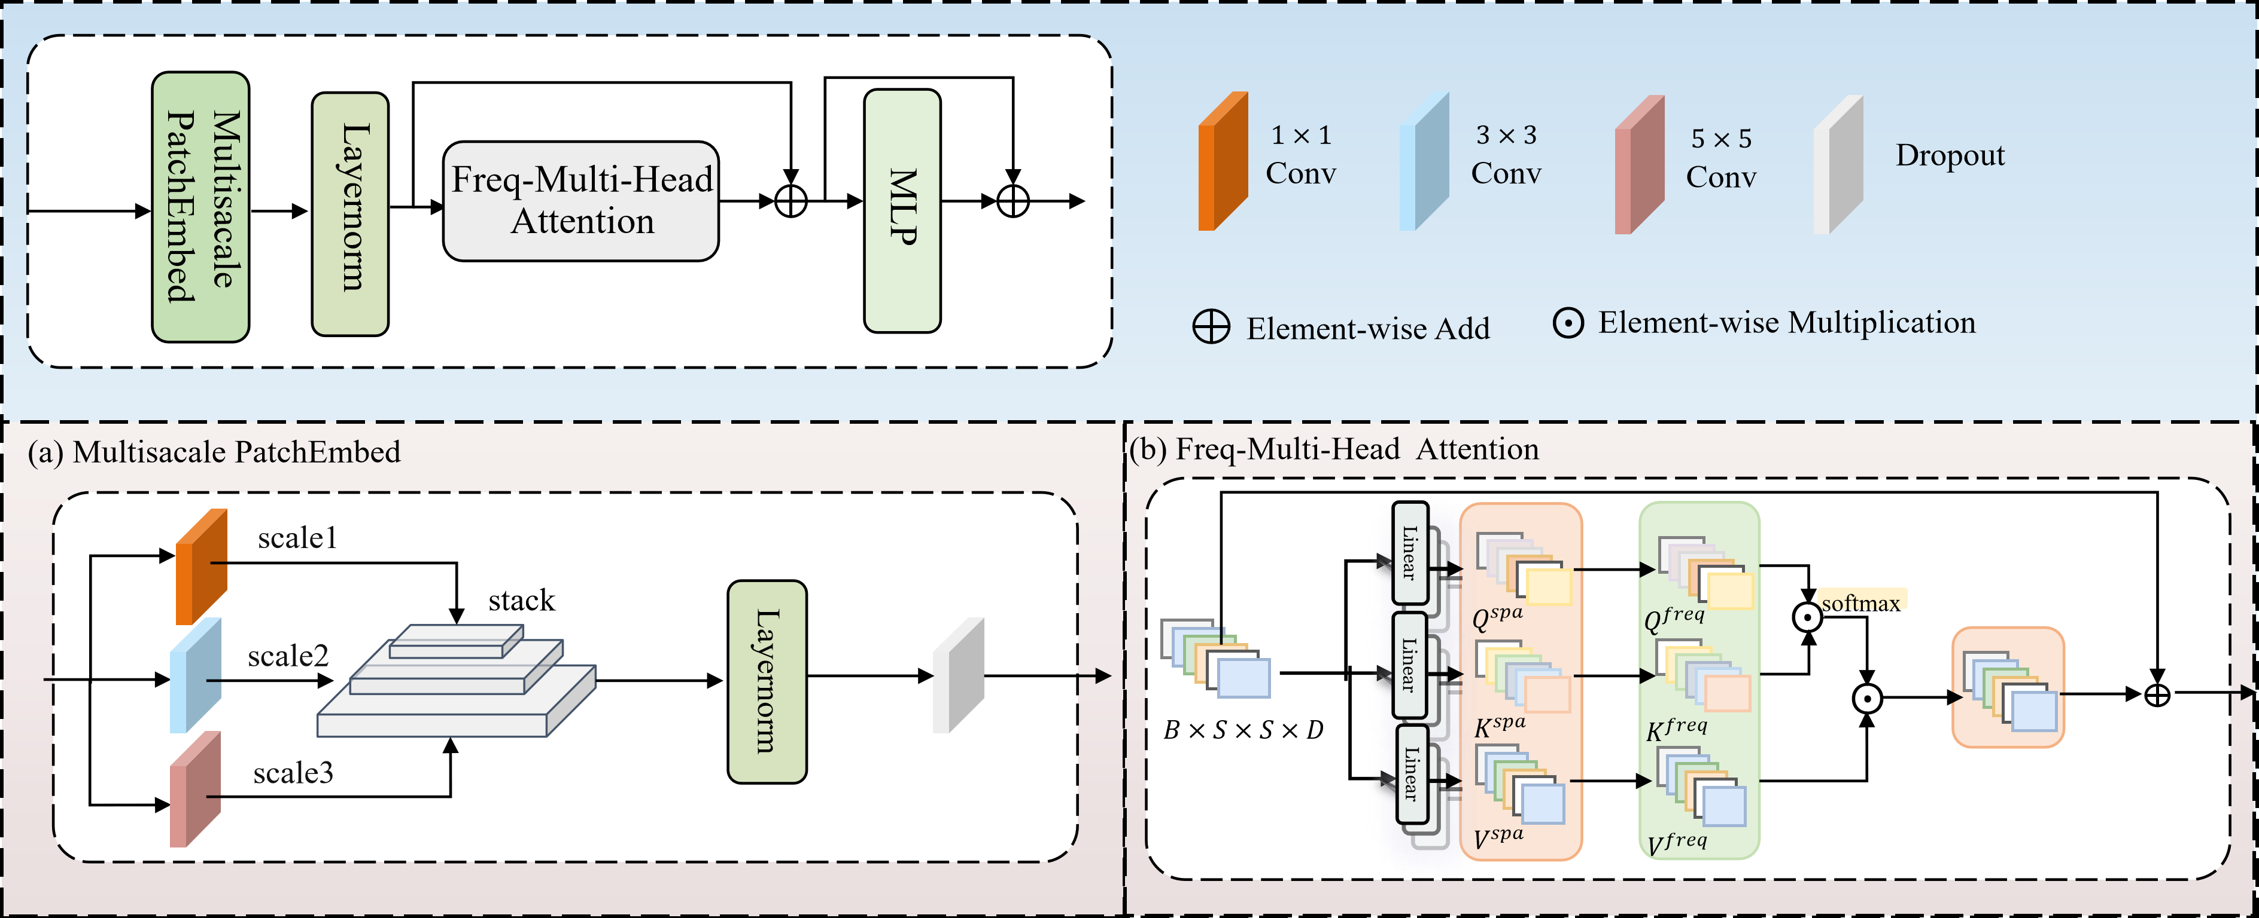
Figure 4. Detailed architecture of FreqViT

4. Response to Comments on the Quality of English Language
Comments 5: Several expressions in the experimental analysis need minor correction: (1) “DEKM gives highest ACC” → “DEKM achieves the highest ACC.” (2) “Higher ACC and NMI on IP come from two factors” → “The improvements in ACC and NMI on IP can be attributed to two factors.” (3) “Class-wise results further support such explanation” → “The class-wise results further support this explanation.”
Response 5: We sincerely thank the reviewer for the thorough proofreading and valuable linguistic suggestions. We fully agree with your corrections, which significantly enhance the accuracy and readability of our manuscript. We have updated the three specific expressions in the experimental analysis section exactly as suggested. Furthermore, following your feedback, we have conducted a detailed proofreading of the entire manuscript. We have refined the sentence structures, corrected minor grammatical issues, and polished the overall academic phrasing.

